An IoT-Model for Monitoring Irrigated Crops
Alternate Title:
IOT Based Smart Farming and Weather Forecasting System
Aim:
The main goal of our project is to develop a smart farming society using IOT in low cost and with more production values.
Abstract:
With the increase in the demands and if you are struggling to ensure efficiency in how you use water in your farm, ways of reducing soil erosion and ensuring minimum degradation, or even minimizing energy input, you are not alone. The need for sustainable agriculture, it is becoming really necessary for farmers to invest a lot in knowledge and more sophisticated machines and devices.
IOT in agriculture is designed to help farmers to monitor vital information like humidity, air temperature and soil quality using remote sensors and to improve yields, plan more efficient irrigation and make harvest forecasts. By some estimates, 10% to 15% of farmers use IoT technologies on the farm, according to data produced by government.
In our smart farming system we share an idea of controlling water usage by getting the sensor data from the agricultural fields using microcontroller. When soil is dry or any condition coded by user to the microcontroller sends a request to Esp32 through transmitter LORA to receiver LORA. The Esp32 transfers the request to cloud database. Cloud analyzes the weather of the present day and acts on the request of microcontroller through Esp32. relay is used to control the motor and a LCD display is used to display the weather condition of the farm.
Through our smart system we tried to figure out the solution for modern day farming problems and to reduce the gap between farmer and technology.

Existing System:
The existing system does not focused on weather forecasting and so even when there is possibility of rainfall the motor will be turned which leads to wastage of water and power. Or even worse situation like damage of crops in the fields.
Proposed System:
In our proposed system we have implemented the weather forecasting system which turns on the motor when there is no rainfall and if there is rainfall the motor will be kept off. Through our system water and power consumption is reduced way more than existing system.

Block Diagram:
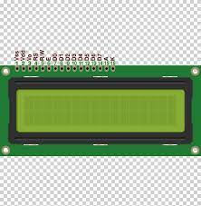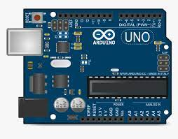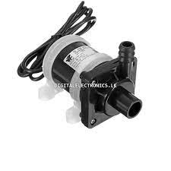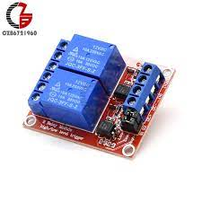
Moisture
12V Relay
Water Pump Motor
16X2 LCD
Cloud Database
Arduino UNO
Esp32
LORA Pair
Rain sensor
Temperature sensor

Hardware Requirements:
- Arduino UNO
- Esp32
- Soil moisture Sensor
- DHT11
- Rain sensor
- Relay board single
- LORA Pair
- 16X2 LCD
- Water Pump Motor
- Board and Adapter
Software Requirements:
- Arduino IDE

